Mia Karlova Galerie presents ‘Poetic Design’.
Duo show of Olga Engel and Sho Ota
will be opened in Amsterdam

15 December 2022 – 10 February 202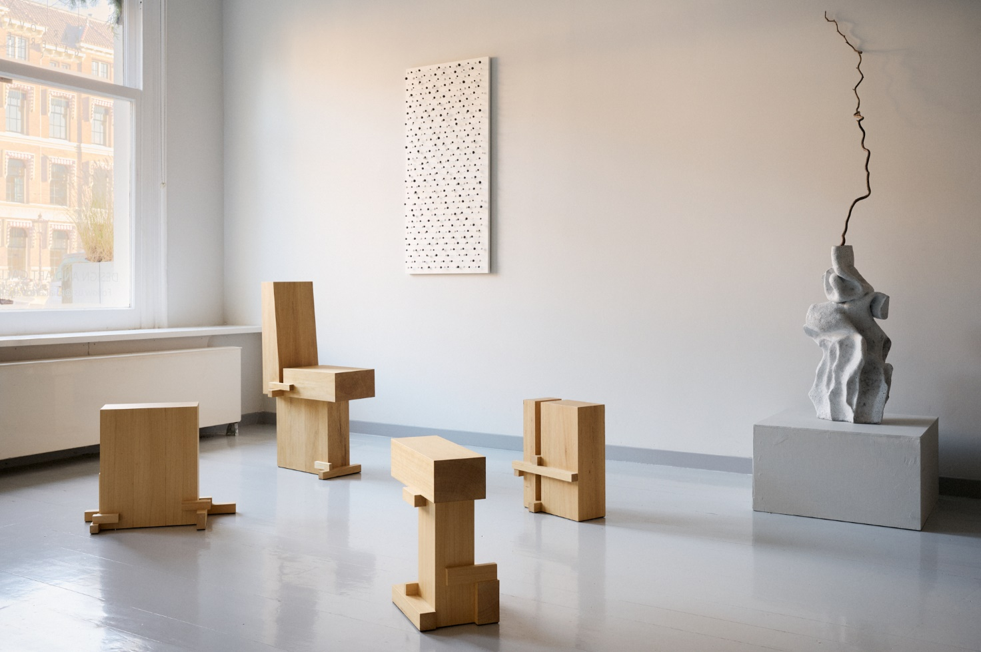 3
Flowers modular seating pieces by Olga Engel; Splint side tables by Sho Ota © Jeroen van der Spek, Mia Karlova Galerie 2022

Amsterdam-based Mia Karlova Galerie will present a duo show of Olga Engel and Sho Ota (15 Décembre 2022 – 10 February 2022) with an exclusive exhibit “Poetic Design” revealing minimalism and sensuality in design, which unite these two artistic practices.

Olga Engel
Olga Engel harmoniously fuses materiality with minimalism and functionality with a light mood and poetic touch of irony. Taking her cues from personal stories, she brings sensitivity and charisma to her work. Her practice is fuelled by the desire to metamorphose ordinary objects into whimsical design pieces by giving them new and unexpected functions.
For the first time the gallery will present a CHARLOTTE collection in Amsterdam. Collectible objects inspired by poetic design of renowned French designer Charlotte Perriand. Minimalistic and ironic tables and consoles are made of warm oak wood.

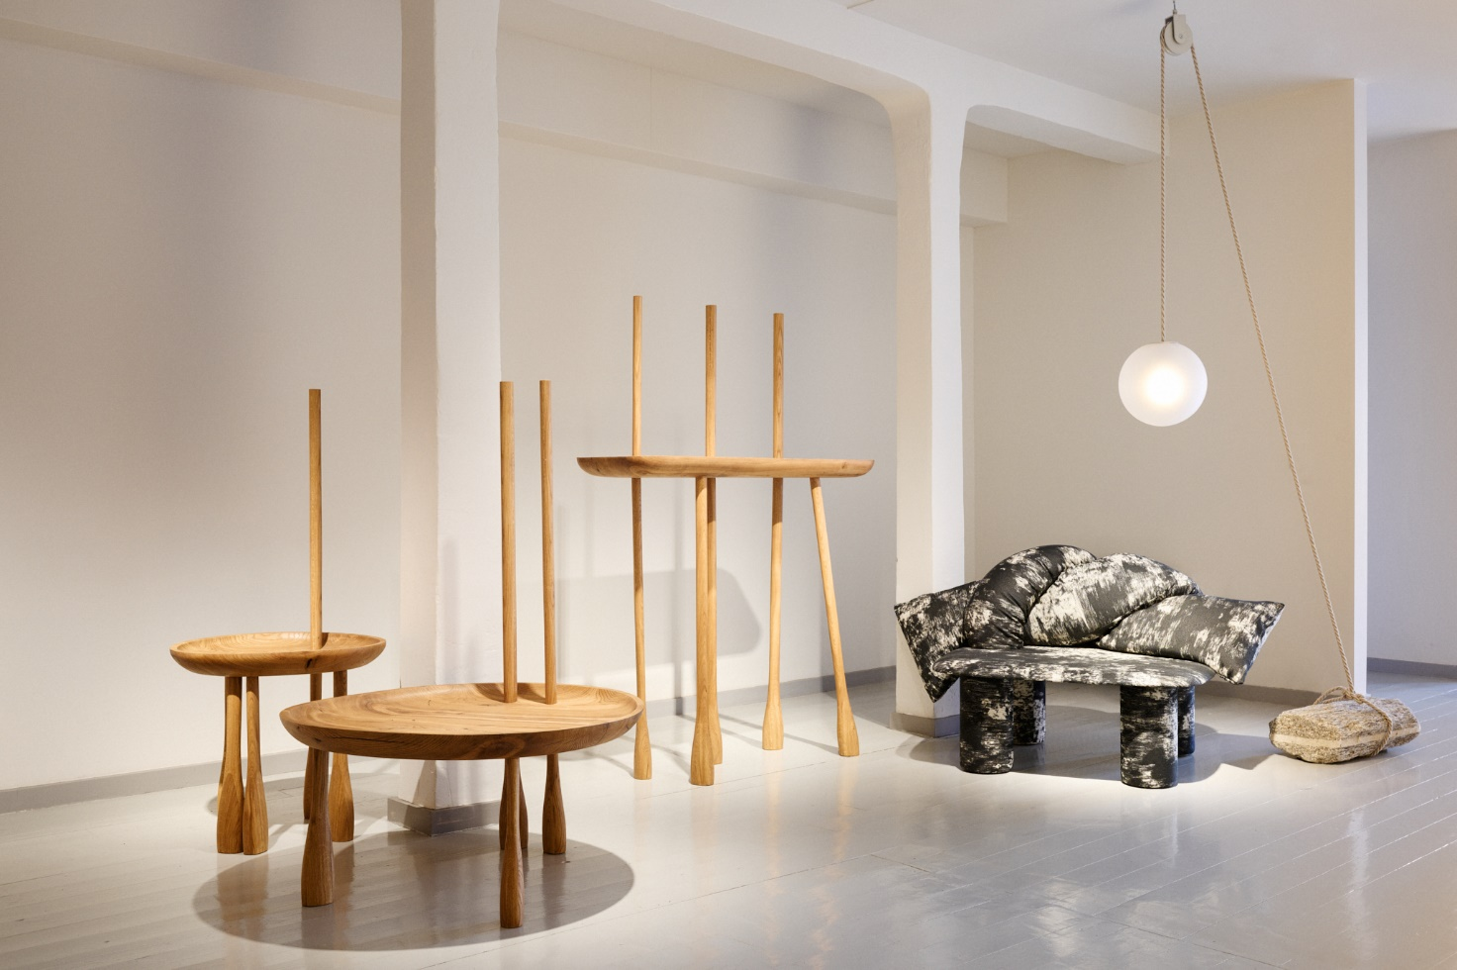

Tables and console from Charlotte series, OBI chair Olga Engel @Mia Karlova Galerie, 2022

Olga Engel: “I have always been inspired by Charlotte Perriand’s approach to design. I have questioned how she found her route to the French hearts, while historically the cultural tradition of design and interiors in France is so luxury and decorative. The answer was: “Her design is simple and poetic. Luxury in simplicity. I think my objects have this poetic touch as well.”
Olga Engel is a successful product and interior designer, who harmoniously mixes luxury with minimalism, functionality and ergonomics with a light mood and a touch of irony. Olga`s design is always a personal story, that involves unique charisma and charm for each and every object and the space itself. She pays special attention to the proportions and harmony, to the quality and philosophy. Olga has participated in PAD Paris, Art Basel and Design Miami. Her works are in private collections in Europe and USA.

Sho Ota
Eindhoven graduate Sho Ota – known for his multi-layered, sculptural designs – will introduce a new series of side tables made of Abachi wood, seeking to push the boundaries of woodcrafting. In his inimitable style, Sho examines the idea of beginning with a minimalist form and subtly building in complexity.

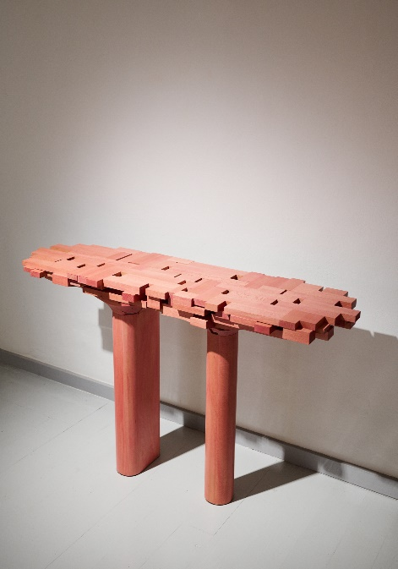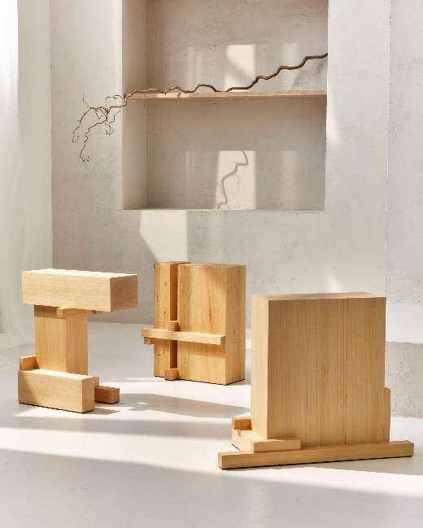
Left: Surfaced console, right – Splint side tables by Sho Ota; Mia Karlova Galerie 2022

For his new Splint chair, Sho has unified a large rectangular mass, which serves as a base, with smaller elements of wood; the main component alone is unstable but when assembled with the secondary parts, it is strengthened, allowing it to function as a table. Usually in furniture production, these parts are hidden or blended within the structure of an object, however, here Sho has deliberately left them exposed, simplifying them and presenting them in a form that is easy to understand. Sho explains: ‘I find such simple, true minimalism without concealment to be beautiful. I find grace and beauty in its honest structure.’

- ENDS -

Press Contact
Mia Karlova: mia@miakarlova.com | +31 6 21313036

About Mia Karlova Galerie
Mia Karlova Galerie gives centre stage to functional sculpture, rallying an intriguing roster of international artists whose experimental practices look upon reuse as a conscious act of new existence: sustainability enriched with a deliberate sense of meaning and the desire to provoke new emotions.

Founded in 2020 by interior designer and curator Mia Karlova, the eponymous Mia Karlova Galerie seeks to form a dialogue between works of various genres through a common emotional language.

Having opened a physical outpost in Amsterdam, Mia Karlova Galerie enthusiastically explores the ever-evolving, cross-disciplinary possibilities of design and art.

miakarlova.com | @miakarlovagalerie

